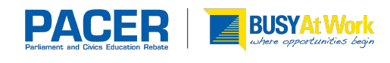

Newsletter / Letter

Parliament and Civics Education Rebate (PACER)

The Parliament and Civics Education Rebate (PACER) guidelines require schools to report the Australian Government funding in the school newsletter or equivalent, or a letter sent to parents/guardians.

Newsletter: If you place an article in your school newsletter, please provide a copy of the front page of the newsletter with the date and issue reference, as well as the article page.

Letter: If you send a letter to parents/guardians please provide a copy of the signed and dated letter, as well as a note showing how the letter was issued to the parents/guardians e.g. mail out, part of tour information pack, attached to the school newsletter.

Below is an example of the wording you can use in your newsletter or letter.

Students from our school will soon be undertaking (or have recently undertaken), an education tour of the national capital. Students will be given the opportunity to participate in a variety of educational programs with a focus on Australia’s history, culture, heritage and democracy.

The Australian Government recognises the importance of all young Australians being able to visit the national capital as part of their Civics and Citizenship education. To assist families in meeting the cost of the excursion the Australian Government is contributing funding of <<$>> per student under the Parliament and Civics Education Rebate program towards those costs. The rebate is paid directly to the school upon completion of the excursion.

